**Patient Information for Baby Immunisations 8 weeks old**

**IMPORTANT INFORMATION ABOUT YOUR VACCINATION**

**Before your child has their Vaccination/s please read carefully prior to your immunisation and inform the nurse if you answer YES to any of the questions. Thank you.**

* Are you feeling unwell / unfit today?
* Are you suffering from a high temperature/fever
* Are you on any medication?
* Do you have a lowered immune system for any reason i.e. medication / disease / Cancer, Leukaemia, Hodgkins?
* Have you had a splenectomy?
* Are you HIV +?
* Are you on high dose oral steroids?
* Have you had any biological therapy (eg anti-TNF therapy) in the last 12 months?
* Have you had any other vaccination in the last 4 weeks?
* Have you ever had any reactions to any previous vaccinations?
* Have you ever fainted after an injection?
* Have you ever suffered from Guillain-Barre syndrome?
* Do you have any allergies?

**Diphtheria, tetanus, pertussis (whooping cough), polio, Haemophilus influenzae type b (Hib) and hepatitis B DTaP/IPV/Hib/HepB** *Infanrix Hexa*

Patient Information Leaflet: <https://www.medicines.org.uk/emc/files/pil.2586.pdf>

**Meningococcal group B (MenB)** *Bexsero*

Patient Information Leaflet: <https://www.medicines.org.uk/emc/files/pil.5168.pdf>

**Rotavirus gastroenteritis Rotavirus** *Rotarix*

Patient Information Leaflet: <https://www.medicines.org.uk/emc/files/pil.201.pdf>

**Using paracetamol leaflet:** <https://assets.publishing.service.gov.uk/government/uploads/system/uploads/attachment_data/file/717281/PHE_paracetamol-menB-A4-2018_01.pdf>

**What to expect after a vaccination leaflet:**

<https://assets.publishing.service.gov.uk/government/uploads/system/uploads/attachment_data/file/853210/PHE_what_to_expect_after_vaccination_English.pdf>

[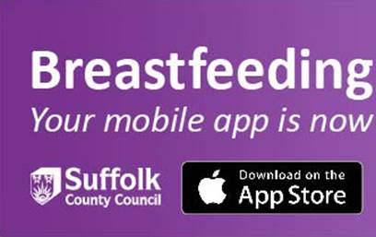](https://apps.apple.com/us/app/breastfeeding-suffolk/id1487694263?ls=1)[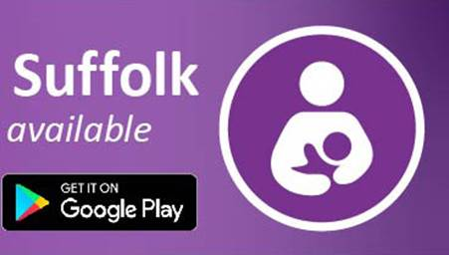](https://play.google.com/store/apps/details?id=com.PaintinPixels.breastfeedingsuffolkandroid)